[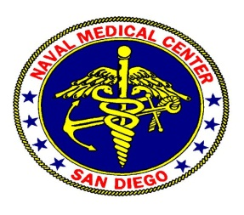](http://nmcsd-as-spfe01/sites/dfa/imd/isd/train/NMCSD%20LOGO/nmcsd_logo.gif)

**NAVAL MEDICAL CENTER SAN DIEGO (NMCSD)**

**GRADUATE MEDICAL EDUCATION**

**AMENDMENT TO RESIDENCY CONTRACT OF AGREEMENT**

1. This Amendment is made as of Click or tap here to enter text., to the Residency/Fellowship Contract of Agreement, between Click or tap here to enter text. and the United States Navy signed on Click or tap here to enter text..

2. **WHEREAS**, the officer’s performance as a resident from Click or tap here to enter text. has met the performance and milestone requirements of the Accreditation Council for Graduate Medical Education (ACGME) and the residency/fellowship program curriculum, the program desires to promote Click or tap here to enter text. to Post Graduate Year (PGY) Click or tap here to enter text. and offer the resident/fellow an additional year of training in the program at NMCSD.

3. **THEREFORE**, the officer and the United States Navy mutually desire and agree to amend said Residency/Fellowship Contract of Agreement for a period of one (1) year by executing this written amendment.

4. NOW **THEREFORE,** in consideration of the mutual covenants and promises contained herein, the receipt and sufficiency of which are hereby acknowledged, the parties agree to amend said Residency/Fellowship Contract as follows:

a.  Click or tap here to enter text. will continue in Click or tap here to enter text. Residency/Fellowship program in the PGY Click or tap here to enter text. year at Naval Medical Center San Diego. The Residency/Fellowship Contract of Agreement is correspondingly amended to be effective from Click or tap here to enter text. to Click or tap here to enter text..

b. All other terms and conditions of the Residency/Fellowship Contract of Agreement shall remain in full force and effect.

5. **IN WITNESS WHEREOF**, the parties hereto have caused this amendment to the Residency Contract of Agreement to be executed by Click or tap here to enter text. and on the respective behalf of the United States Navy by their duly authorized representative effective as of the day and year first above written.

________________________________ Click or tap here to enter text.

Click or tap here to enter text., Click or tap here to enter text., MC, USN

________________________________ Click or tap here to enter text.

Accepted on Behalf of the US Navy

Click or tap here to enter text., Click or tap here to enter text., MC, USN

Click or tap here to enter text. Program Director

Naval Medical Center San Diego